How to use Digimaster 3?
- You should know how to check the vehicle list. When you open the car list, you will see the following picture, it will show 4 areas: Europe, America, Japan & Korea. Where you are from, you should check which area. If you are from America, you need to choose America.

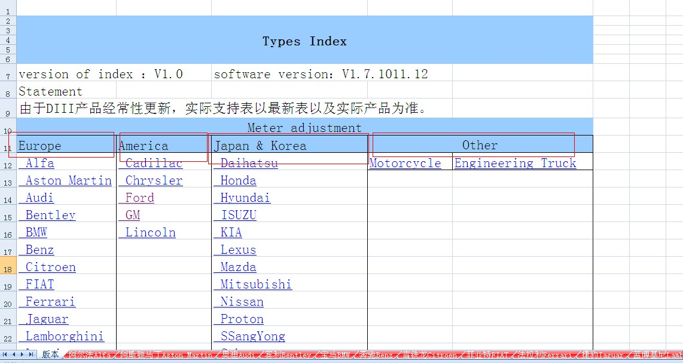

- If you choose America, and you want to do Ford cars, please click “Ford”, you will see the following picture, you will see three columns” Type, Information and Adapter”.
Type: It is car type which Digimaster 3 can do.
Information: It is the car information.
Adapter: It is used to program mileage for your car. Please don’t do all cars by using the obd cable, it is very important. Digimaster 3 does most cars by adapter card. You can find the adapter card in the Digimaster 3 suitcase.

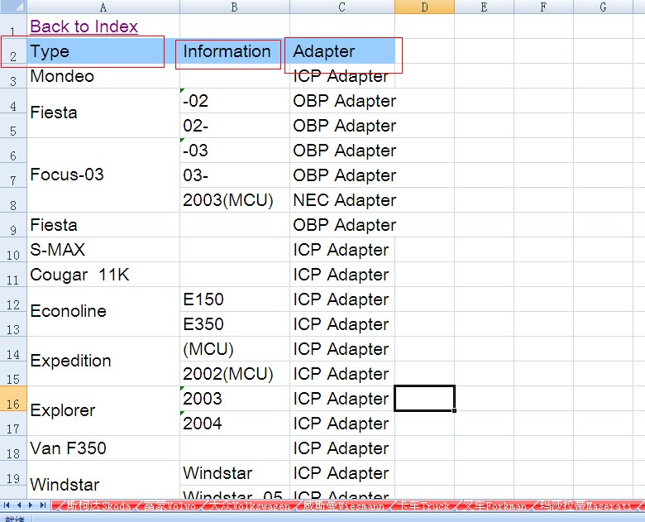

- After you see the Adapter Card, if you want to do “Fiesta”, you need to find “OBP Adapter” on your Digimaster suit case, there are many adapter on your suit case. Then remove the dashboard of your car, which will tell you the chip information, and take out of the chip from your car, then put the car chip to the “OBP Adapter”. And I think you can know how to program mileage for your car.

- If you want to do other cars, you can click “ Back to index”.
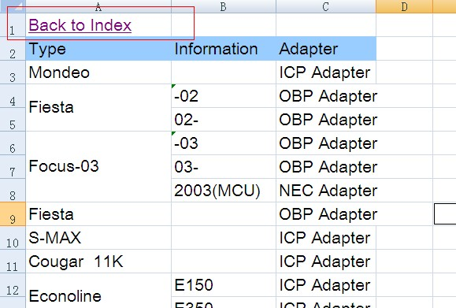

- Now I tell you which car you can do with OBD Cable. Check on the Europe Area, click “VW”, you will the following picture, only these cars can be done by OBD II Cable.
